Apache kafka_2.13-3.8.0 Configuration

Installation in Windows 10

Download kafka_2.13-3.8.0: https://kafka.apache.org/downloads

Go to the folder C:\kafka\config

1. Edit zookeeper.properties
dataDir=C:/kafka/zookeeper-data

2. Edit server.properties
log.dirs=C:/kafka/kafka-logs

3. Start Zookeeper process from C:\kafka folder
Open a Command Prompt
c:\kafka>.\bin\windows\zookeeper-server-start.bat .\config\zookeeper.properties
[Make sure that JAV_HOME is set to C:\Java8]

4. Start kafka server
Open a Command Prompt
c:\kafka>.\bin\windows\kafka-server-start.bat .\config\server.properties

5. Create a topic from C:\kafka\bin\windows
Open a Command Prompt
C:\kafka\bin\windows>kafka-topics.bat --create --bootstrap-server localhost:9092 --topic test
Created topic test.

6. Start a Producer
C:\kafka\bin\windows>kafka-console-producer.bat --broker-list localhost:9092 --topic test

7. Start a Consumer
C:\kafka\bin\windows>kafka-console-consumer.bat --topic test --bootstrap-server localhost:9092 -from-beginning

Test Producer & Consumer by ingesting data:

From Producer window push a JSON/any text data:
C:\kafka\bin\windows>kafka-console-producer.bat --broker-list localhost:9092 --topic test
>{"Name: "John", "Age":"31", "Gender":"Male"}
Check it in Consumer Window:
C:\kafka\bin\windows>kafka-console-consumer.bat --topic test --bootstrap-server localhost:9092 -from-beginning
{"Name: "John", "Age":"31", "Gender":"Male"}

Conclusion:
You can push any text from the producer window and it will reflect in Consumer window in real time mode.

Integrating Kafka and PySpark:

Step 1: Create a new Python file in Jupyter: Kafka-Spark.ipynb
Step 2: Type the following code in this file

Cell-1:
# To produce messages programmatically and send to the Consumer
from pyspark.sql.functions import *
from pyspark.sql.types import *
from pyspark.sql import SparkSession
from kafka import KafkaProducer
import json

# Initialize Spark Session with Kafka dependencies
spark = SparkSession.builder \
.appName("KafkaStructuredStreaming") \
.master("local[*]") \
.config("spark.jars.packages", "org.apache.spark:spark-sql-kafka-0-10_2.12:3.4.0") \
.config("spark.sql.streaming.checkpointLocation", "file:///C:/tmp/kafka-checkpoint") \
.getOrCreate()

spark

Cell-2:
kafka_df = spark.readStream \
.format("kafka") \
.option("kafka.bootstrap.servers", "localhost:9092") \
.option("subscribe", "test") \
.option("startingOffsets", "latest") \
.load()

Cell-3:
from datetime import datetime
# datetime object containing current date and time
now = datetime.now()
# dd/mm/YY H:M:S
dt_string = now.strftime("%d/%m/%Y %H:%M:%S")

# Create a Kafka producer and
# Serialize JSON data
producer = KafkaProducer(
bootstrap_servers='localhost:9092',
value_serializer=lambda v: json.dumps(v).encode('utf-8'))

# Sample data (10) to send to the Consumer
id = 1
for i in range (10):
msg = dt_string + " Hello Kafka Message No. " + str(i)
data = {"id": i, "message": msg }
# Send the JSON message
producer.send("test", value=data)
producer.flush() # Ensure all messages are sent

print("Message sent successfully!")

Step 3: Run your Consumer Window so that you can view the output.

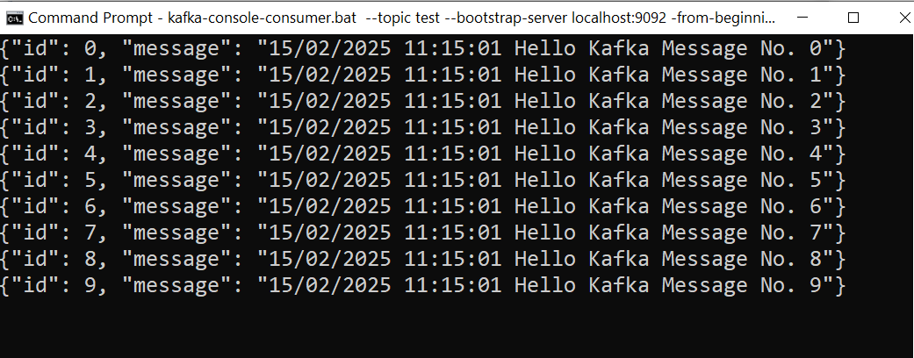

Conclusion:
You have successfully produced 10 messages in Python and sent it via kafka to the Consumer/Subscriber routed through the topic called "test".

